WEB APPLICATION PENETRATION TESTING
Password Reset Broken Logic
Authentication Assessment Report
Platform | PortSwigger Web Security Academy
Tooling | Burp Suite Community Edition
Issue | Reset token not bound to the requesting account
Severity | CVSS v3.1 9.1 — Critical (indicative)
1 Summary
The Password Reset Broken Logic lab demonstrated a flaw in the password-reset process. A reset token generated during the flow was not correctly bound to the account being modified. By changing the username parameter from wiener to carlos in the reset request, the password for the target account could be changed. The lab then confirmed successful completion.
2 Objective and Scope
Objective: determine whether the password-reset process securely associates a reset token with the account for which it was issued.
Scope: the intentionally vulnerable PortSwigger Web Security Academy lab environment.
3 Method
- Initiated the password-reset process using the provided wiener test account.
- Captured the password-reset request in Burp Suite.
- Changed the username parameter in the request to carlos.
- Submitted the modified request and observed the server response.
- Confirmed that the lab was solved and the carlos account page was accessible.
4 Finding
The server accepted a password-reset request in which the username parameter identified a different account from the one that initiated the reset flow. This indicates that the reset token was not properly validated against its intended account.
Core issue: the server does not enforce token-to-account binding. A reset token must only authorise a password change for the specific account for which it was generated.

5 Evidence
Evidence is presented in chronological order. Reset-token values, session cookies, and password values have been redacted from the report copies.
Figure 1 — Original password-reset request
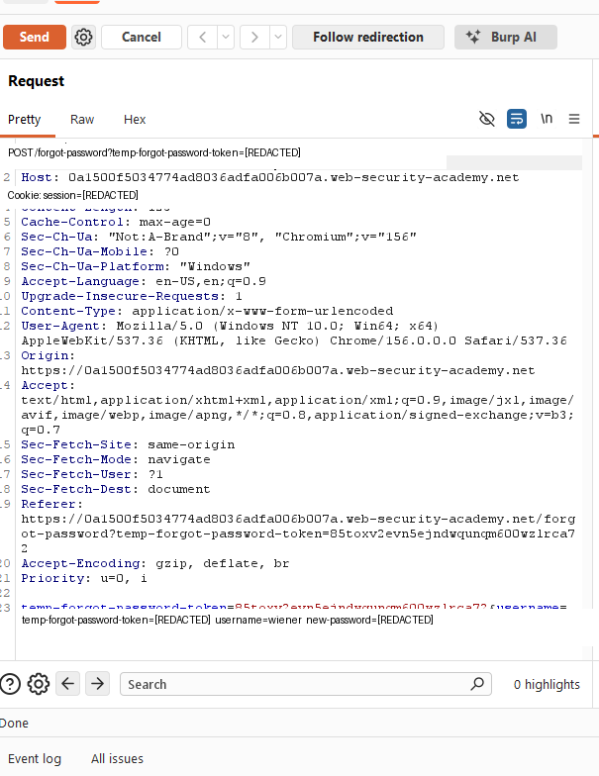
The password-reset request is captured after initiating the flow for the wiener test account.
Figure 2 — Modified password-reset request
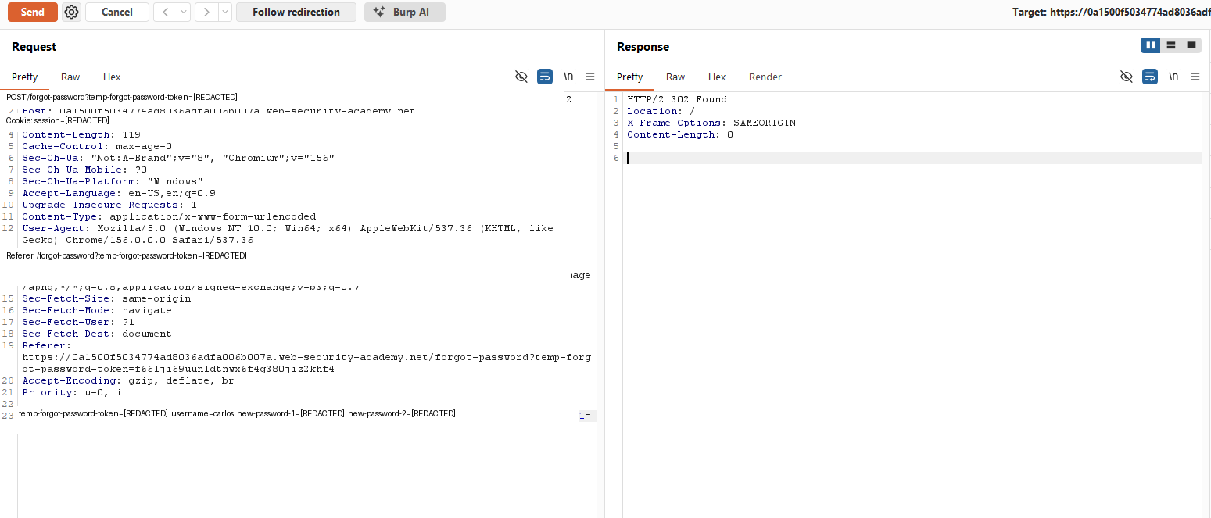
The username parameter is changed to carlos while the reset request is submitted.
Figure 3 — Successful account access
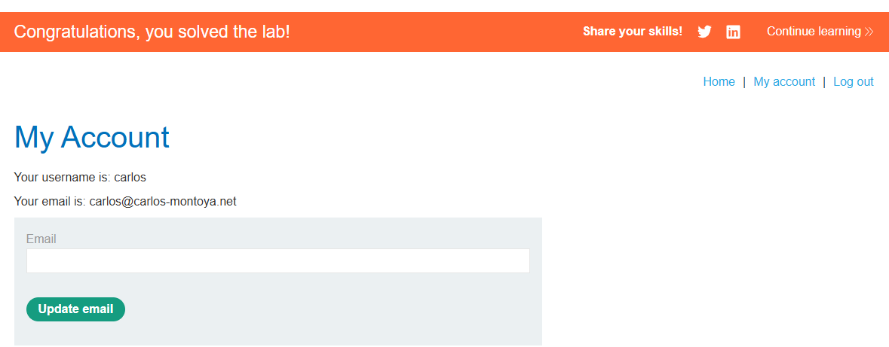
The account page identifies carlos and the PortSwigger success banner confirms the lab was solved.
6 Impact
An attacker able to exploit this flaw may be able to reset another user’s password and take over that account. Account takeover can expose private information and allow unauthorised actions using the compromised account.
7 Severity
9.1  CRITICAL | CVSS v3.1 (indicative)  Vector: CVSS:3.1/AV:N/AC:L/PR:N/UI:N/S:U/C:H/I:H/A:N

The score assumes the vulnerable reset endpoint is remotely accessible without authentication and that successful exploitation can result in account takeover with high confidentiality and integrity impact. This is an indicative lab-based assessment; a real deployment should be rescored using its actual context and impact.
8 Recommendations
- Bind each reset token to the specific account for which it was generated.
- Validate the token and its account association on the server for every reset submission.
- Do not trust a client-supplied username to determine which account is being reset.
- Make reset tokens single-use and expire them after a short period.
- Invalidate outstanding reset tokens after a successful password change.
- Notify users when their account password is changed.
9 Conclusion
The lab demonstrated that insufficient validation of the password-reset token’s account association allowed the reset flow to be used against another account. Password-reset tokens must be securely bound to the intended user and validated server-side before a password change is accepted.
Reference
PortSwigger Web Security Academy — Password reset broken logic: lab-password-reset-broken-logic
Disclaimer
This assessment was conducted in an intentionally vulnerable PortSwigger training environment. Testing must only be performed against systems for which explicit authorisation has been obtained.

